**Pre-school Play and Learning Newsletter for 11th – 15th February 2019**

*Our wonder words this week have been: **fierce, fearsome, ferocious, friendly, kind, shy and other describing words used in our stories \***

**Play and Learning Highlights:**

We continued the children’s enjoyment in the Snuggledown film this week by focusing on the story of ‘We’re Going on a Bear Hunt’. The builder’s tray has been set up for small world play with resources to retell the story and the children have made great use of these. It is clear the words of the story are etched into their memories! Their play has also developed the story and taken it off on many other tangents!

As the children know the story so well that we have been giving them opportunities to make up different versions of the story, choosing their own ‘hunt’s to go on. We have had all sorts of different animals being ‘hunted for’ including unicorns, dragons, monsters and dinosaurs – plus a sea plane and a rocket! We have talked about what sort of dinosaur etc they are hunting for, e.g ‘fierce, shy, kind etc, which has helped develop their describing vocabulary. They have been encouraged to use story maps to draw out their stories and these have helped with them verbally retelling their tales – wonderful to see in action.

The sunshine has drawn all the children outside – we have had super collaboration to create waterways and ramps, plus lots of squeals as the children utilised the dragon head from last week to re-enact ‘We’re going on a dragon hunt’!

Monday morning saw this week’s ‘Baking Buddies’ work together to make sugar free apple and banana muffins (recipe included on this email). The children are beginning to grasp the concept of the ‘Baking Buddies’ and it has been lovely to see the sense of pride and happiness they feel when the rest of our crew express their thanks and appreciation.

**Out & About sessions:** We used our Out & About sessions this week to inspire our own ‘We’re going on a dinosaur hunt’. The children took this idea and ran with it! Some great language and imaginative skills were demonstrated and lots of excitement when we actually found some dinosaurs too! We will be making a story book from the photos we took for the children to use in the book corner. Unfortunately we weren’t able to do as many Out & Abouts this week as we’d planned due to staff sickness.

**Sounds and Letters/language focus:**



The Flying Fish have continued the focus on blending sounds to hear ‘consonant – vowel – consonant’ (cvc) words. We have played Bingo and ‘Walk the Plank’ games which have given them lots of opportunities to practice and develop this skill.

The Starfish children have focused on ‘We’re going on a Bear Hunt’ and played with the ‘sound’ words from the story. They have also used musical instruments to accompany the story.

**Ideas to support your child at home:**

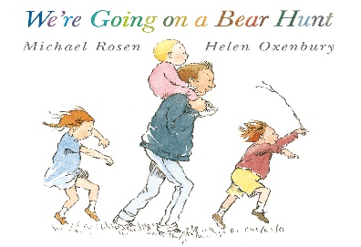

* *We’re going on a Bear Hunt is a great story for children to memorise and if you don’t have a copy of it at home we would strongly recommend borrowing one from the library or buying one. As children become familiar with the story they are often likely to be found ‘reading’ it themselves, saying the well learnt phrases from the book as they look at the pictures.*
* *Whilst you are Out & About with your child this half term pretend that you are going on a hunt for something. Let your child decide what it could be and then say the phrases from the story ‘*We’re going on a . . . .hunt, we’re going to catch a big one. What a beautiful day. We’re not scared!*’ As you come across possible scenarios (e.g a puddle, a hill, a stile) use them in your ‘hunt’ – ‘We can’t go over it, we can’t go under it – Oh no! We’re got to go through it!’ Have fun!*