Pre-school Play and Learning Newsletter for 15th – 19th July 2019
*Our wonder words this week have been: Ahoy matey! Captain, compass, cutlass, pieces of eight, rigging, treasure, booty, hook.
Play and Learning Highlights:
Another great week of ‘piratey’ adventures! Thank you so much for sending your children in as pirates as it’s added to the fun of the week. We have had lots of pirate role play, particularly in the water tray, sand tray and outside. The pirate costumes has also inspired lots of creating with the resources at the Creating Table with eye patches, head bands and pirate ‘princess’ crowns being made.
The lovely sunshine has finally prompted our vegetables to start growing – and eager eyes have been busy spotting and counting the tomatoes and peas which have begun appearing in the veg box. Growing vegetables is such a great way of encouraging the children to notice change and understanding the process of growth. Their knowledge of what plants need to grow and when you can harvest them is wonderful. We have also had peas for snack time which the children have enjoyed podding and counting (fine motor and counting skills without them even realising!).
There has been lots of action in the home of the house sparrows (if you look up at the top of the pre-school roof in the front apex, you will see a hole where they live) – with Mummy and Daddy being very busy filling hungry tummies. The chicks are now visible and the children have loved watching them being fed by their parents, using the binoculars to help them see them more clearly.

Out & About sessions: On Monday we went to Illogan woods to practice our counting skills with sticks – however in true Out & About style the session turned into a bonfire building challenge with great team work to move HUGE sticks (branches to be honest!). The children’s encouraging comments to each other were so lovely to hear as they moved some enormous branches to the bonfire area.
Those cheeky pirates set posed us another problem on Tuesday and Friday – they’d kidnapped our cat!! Luckily we found a map with an ‘X marks the spot’ on it which we decided to follow. It took us all the way to the little woods where we were able to find and rescue our cat! Again, great team work in deciphering the map and deciding which way we needed to go.
Sounds and Letters/language focus:

We have spent lots of our group sessions this week singing pirate songs and sharing pirate stories. The Flying Fish have been encouraged to think of rhyming words which fit in with the songs, and also using their phonic knowledge to begin to decode simple words in some of the books we are using. The Starfish have been filling in the gaps in songs and using their knowledge of some familiar pirate stories to ‘read’ them to their friends. These sort of activities really help develop children’s auditory memories (the ability to remember things they have heard), which in turn helps encourage concentration.
Ideas to support your child at home:
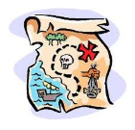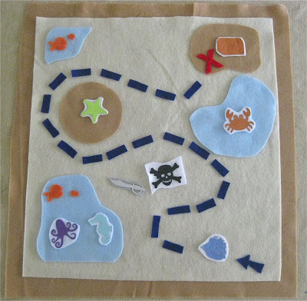
- Most children love using a treasure map to use to find some treasure! The map doesn’t have to be very detailed – but must include an ‘X marks the spot’. Why not draw a simple one and use it to find treasure in the house/garden/further afield. Whilst your child is using the map model language such as around, left, right, turn, go past, direction etc as this will help develop their positional language.
- Encourage your child to draw a treasure map for you to follow – remind them that they need to put an X to show where the treasure and that they need to explain where things are on the map. Again this will help develop language skills and mark making skills too.

