Pre-school Play and Learning Newsletter for 24th – 28th June 2019
- *Our wonder words this week have been: queue, dinner tray, PE Kits, nervous, register, kind, selfish, helpful.
Play and Learning Highlights:
This week we have focused on ‘Getting ready for school’ with the Flying Fish children, introducing a ‘school corner’ for school role play, having all the uniforms of the schools the children will be attending for fancy dress and practicing getting into and out of our PE kits for some fun PE lessons in the playground. The children have also been taking it in turns to use our school dinner trays at lunch time, with their packed lunch items placed in the correct parts of the tray. Walking with a filled tray is not an easy task when you are little but having the time and space to practice really helps the children when they are having to encounter this task for real. The whole point of all these tasks is to make going to big school a very normal, well-practiced, frequently visited concept so that it doesn’t seem so big and scary.
We have also been playing games which encourage cooperation and working with others – a skill which is important both for school and life beyond. Its lovely to observe the children actively supporting their peers and encouraging them to complete a task or try something and really highlights the lovely relationships they have all developed with each other.
Other highlights this week have included red ripe strawberries (with problem solving challenge of how to share so everyone gets to taste a little), lots of child initiated physical challenges involving various pieces of equipment outdoors, small world play in the rice tray and finger muscle strengthening play in the water tray with squirty bottles and sprays. So much learning and so much fun – a perfect week at pre-school!
Out & About sessions:
At the start of the week we visited the little beach to create art from the natural materials available. The grownups drew a picture frame for each child and they then use the sand, seaweed, pebbles and other bits of treasure to create pictures. This week the tide was in so the children got to jump waves and try and make the biggest splash with pebbles. There was lots of counting in between the waves and comparing of sizes with pebbles. The little beach is such a lovely, safe spot for us to use – always providing us with different things to see and do.

Sounds and Letters/language focus:

The Flying Fish have taken part in various activities which have covered all the different phonic skills we have focused on this year in preparation for us writing their transition reports.
The Starfish have focused on another Mr Gumpy story this week – this time ‘Mr Gumpy’s Motor Car’. It uses the characters from the ‘Mr Gumpy’s Outing’ book and has been really good for talking about kindness, selfishness and helpfulness. The children have also been introduced to the word and concept of an ‘excuse’, coming up with excuses for each of the different animals in the story. Apologies if they use any of them at home when you want them to do something! The children have really enjoyed revisiting the characters and have used their absorption of the text from the previous book to aid their retelling of this one.

Ideas to support your child at home:
Flying Fish – encourage your child as much as possible to get dressed/undressed by themselves, showing them how to turn clothes the right way around and how they can work out if they have their shoes on the right feet.
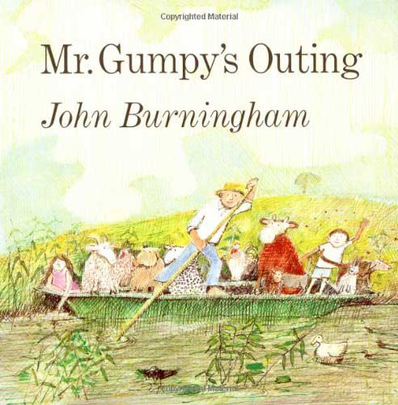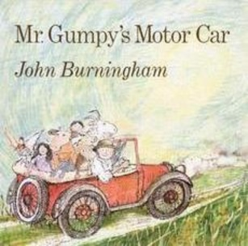
Starfish – See if your children can tell you about the stories of Mr Gumpy which they have listened to and talked about over the past couple of weeks. Can they tell you what happened in the story, who went in Mr Gumpy’s boat or car and if the animals were helpful or not. Retelling or talking about a story which they have heard frequently is great for supporting their memory and language skills.

