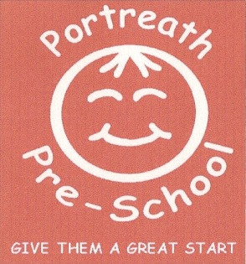
June Newsletter 2016

Welcome
A big thank you to Kelvin Teague (Layla’s dad) who has ran the London Marathon for us in April and raised £550. This will go towards a wooden Kitchen for outside, which the children have enjoyed playing with already. Thank you to everyone that sponsored Kelvin.
Planning and Activities
For the rest of the summer term we will be looking at ‘Sleeping’, ‘Keeping healthy and safe’, ‘Beach and boats’. We are planning to do a beach day on 13th July for all the children (more information to follow).
Fundraising
Due to a clash of events in the village this year’s summer fayre which was due to take place on 25th June has now been changed to Wednesday 6th July 3pm-4.30pm at Pre-school. There will be tombola, face painting, a raffle, refreshments and cakes for sale and a second hand school uniform stall. Lisa’s ‘Delicious Wishes Ice Cream Van’ will also be parked outside. Your child should have brought home a letter with more information regarding the afternoon and also raffle tickets for you to sell, if you need more tickets please ask.
It would be great if each child could fill up a jar for the tombola stall and donation of cakes for the day will be greatly appreciated and any old Portreath School Uniform. Please remember we need items for the summer hampers that will be used as prizes for the raffle, there is a list on the notice board inside pre-school.
Bags 2 school
Monday 4th July there will be a collection from ‘Bags 2 School’. They pay schools and charities for bags of jumble, please fill as many bags as possible a bag will be sent home with each child if you need more them please speak to a member of staff (bin bags are fine). This has been a great fundraising event for the Pre-school in Previous collections.
Please bring to pre-school either on Friday 1st July at 3pm of just before 9am on Monday 4th July.
Parent’s partnership
On Monday 4th July we will be holding a parents evening for all parents, you will be able to have an individual meeting with your child’s keyperson. Flying fish parents you will be able to look and read their transition report that will be going to your child’s new school. There is an appointment sheet on the registration board inside preschool for you to book an appointment.
Flying Fish ‘Graduation evening’ will be on Wednesday 20th July 6.30pm. This is a special evening to celebrate the transition of the Flying Fish to ‘big’ school, which parents and the Flying Fish children attend.
Summer Term
Could you please remember to put sun cream on your child before they come to pre-school, we will reapply the sun cream throughout the day. If your child needs their own sun cream please put in in their bag.
September 2016
From September 2016 we will have spaces for children at the pre-school so please let family and friends know, they can come in have a look around pre-school and put their child’s name down for September.

Important Term Dates
Pre-school summer fayre – Wednesday 6th July 3pm – 4.30pm Pre-school
Graduation Evening (for school leavers) – Wednesday 20th July 6.30pm
Training Day Pre-School will be closed to Children - Friday 22nd July 2016
Training Day Pre-school will be closed to children – Monday 5th September 2016
New Term starts- Tuesday 6th September 2016

Thanks for your continuing support from everyone at Portreath Pre-School.

