Play & Learning Newsletter
27^{th Sept} – 1st October 2021
Brother, sister, family, sprinkle, crumble, chop, slice, sauce
Wonder words to use with your child:

There have been some delicious smells wafting around the pre-school this week as the children worked very hard to make our home grown tomato sauce and blackberry and apple crumbles. Both activities have been great for encouraging listening skills, concentration and physical skills which help develop finger muscle strength (essential for being able to hold marking making tools with control and co-ordination). The children enjoyed using words such as sprinkle, spoon, chop, slice as they prepared the vegetables and fruit that they needed. The children have loved closely monitoring our tomato plants since we planted them back in the summer and it have been so lovely for them to be able to pick and then use the produce that they have grown (plus observe what happens when the slugs, snails and caterpillars get to them before we, but accepting that the insects have as much right to them as us). A huge thank you to everyone who donated blackberries to us – and Elvie Rose and Isambard for the apples!

With some of the left-over blackberries we had fun creating blackberry paint. The children loved mixing and exploring how to create the colour that they wanted – we had lots of different shades created!
Other highlights this week have included:
- pizza (oregano smelling) playdough – perfect for halving and slicing plus talking about favourite foods as the children created and chopped,
- ramp fun with a big box – and some wonderful problem solving and critical thinking skills,
- wet weather play in the heavy rain (oh how it rained!) with chalk paint creating in puddles – very therapeutic and calming activity,
- printing with everyday objects in paint – great for encouraging talk about shapes and imaginative use of resources.

Sounds and Letters/language focus: We are continuing our focus on developing listening skills and this week we have used the instruments to play a ‘guess who’ game, plus lots of exploration of the different sounds the instruments make, using our self-control to beat out rhythms in songs and different levels of noise.

Out & About sessions: No sessions this week but, weather permitting, we will be beginning our proper sessions of these next week with the Flying Fish children.

Ideas to support your child at home: 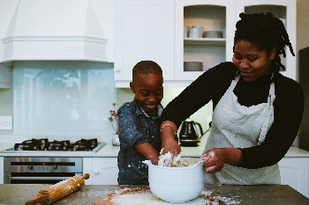
Children LOVE to help with cooking and it’s a fantastic way to develop so many different types of skills. You’d be amazed with how competent they can be given the right tools and task! Always best to get them to help when you have the time to take it slow – and more importantly – not stress about the finished product or mess involved in making it. Seeing their finished product gives children an amazing sense of pride and self-achievement, such an important feeling for little ones to experience.

