Play & Learning Newsletter
9th – 13th Feb 2026
Chinese New Year, chopsticks, celebration, Gung ho fat choy!
Wonder words to use with your child:

Gung Ho Fat Choy! Chinese New Year has been well and truly celebrated this week at pre-school with lots of children demonstrating a very keen interest in how others celebrate this festival of spring and welcoming in good luck. We all began the week with a viewing of Cbeebies ‘Let’s Celebrate Chinese New Year’ .These programmes are a fantastic way of introducing children to the different festivals that are celebrated in this country and around the world, always shared through the experiences of a young child. Throughout the programme we talked about the similarities between how Chinese New Year is celebrated and how Christmas and other special occasions are celebrated. Many of the older children are beginning to understand that celebrations often involve feasts, family and friends coming together, decorating the house, music and visiting places that are special to us. This concept is a really important one as it helps build up their understanding that no matter where we come from or how we live our lives there are always similarities between us and things that we can bond over.
Snack time on Monday was lots of fun with noodle eating with chopsticks – very tricky and required lots of persistence and determination! Baking buddies prepared and served these Chinese foods to their friends to try. They made sweet and sour vegetables, noodles, spring rolls and prawn crackers. They also counted the correct number of plates out and shared the food equally between them before serving their friends!
Other popular play & learning opportunities this week have included our Chinese Restaurant, making Chinese good luck red envelopes filled with pretend money (something that is given to children at Chinese New Year), making decorations to hang in the restaurant and lots of fun with friends in rice sensory tray immersing themselves in its properties. It also encouraged lots of lovely maths language.
The week finished off with a focus on Valentine’s Day and what it means and we had lots of lovely discussions about who they children would like to give Valentine cards to, ranging from pets to friends to grandparents in particular. It also tied in beautifully with the colour monster story from last week and exploring the feeling of love. Making their own cards was a great opportunity for developing those mark making skills and many children now understand that marks hold significance which is an essential first step in their understanding of the concept of writing. All those little lines and wiggles you see drawn over their pictures and paper mean something to them and is their first attempt at ‘writing’ and not to be dismissed!

 Sounds and Letters/language focus: The Flying Fish have been introduced to the letter sound ‘’s’, ‘p’, ‘t’ and ‘a’ so far and this week we are re capping all four sounds. We have been sorting food objects according to their initial sounds all based on the sounds that they have learnt so far. ( we used two letters at a time and they had to decide which letter/pile the food item belonged on. We played I spy with initial sounds.

The Starfish have been listening to dragon music and moving freely to it with scarves to move with them, They have also been singing the 5 little dragons song with props and Dragon dragon turn around song.
 Out & About sessions: We visited Harbour House on Monday to make Chinese Dragons and the children then made them dance around the room to Chinese dragon music which the residents loved as much as they did.
Despite the relentless wet weather we have had a lovely out and about through the woods and also one to the play park both full of outdoor learning opportunities.

Ideas to support your child at home:
Your child may be keen to share the cbeebies ‘Let’s celebrate Chinese New Year ‘ with you and talk about what we did at pre-school this week. They all loved using chopsticks for snack and in the role play area. Using them is a fantastic way of developing the muscles and co-ordination in their fingers which will ultimately help them gain better control over pens and other mark making tools. It’s also great for building up persistence and determination - two attitudes which are essential for success in learning.
Also, you could have a go at the 5 crispy pancakes I’m sure lots of you will enjoy pancakes over half term for pancake day so maybe get your children as involved as possible with the shopping, making and serving of them. We will be using the story The runaway pancake after half term and having a pancake focus all week. We will also learn the 5 crispy pancake song below.
Have a wonderful half term.
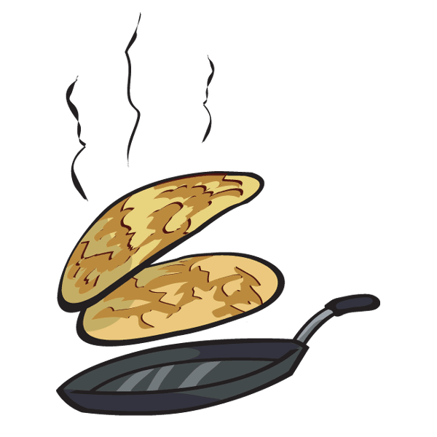

Five Crispy Pancakes
Five crispy pancakes in a frying pan,
Flip them and toss them and catch them if you can.
Along came (choose a child),
For a pancake one day
Sprinkled it with sugar and took it away.
Four crispy pancakes in a frying pan...
It is to the tune of ‘5 currant buns in a bakers shop’ and the idea is that you choose a different person to come and take the pancake away each time. You could use the names of people in your family or line up some of your child’s teddies to pretend to take the pancakes away. We will use play dough pancakes but they could be made of anything – paper, card, material, lids from jars etc. It is a great song for developing mathematical understanding and can lead on to talking about less/more/taking away etc with the older children.

