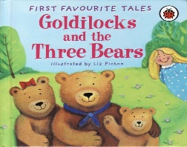 Play & Learning Newsletter
5th October – 9th October 2020
Large, huge, medium, middle sized, small, tiny
Wonder words to use with your child:

This week we have focused on the story of ‘Goldilocks and the three bears’ – another great story for supporting the children’s language development, plus their understanding of ‘size’ words and ordering by size. The children have taken part in ‘action stories’ out in the playground and have shown a good ability to use everyday items as props in the story as we’ve acted it out. We have also had a ‘story bag’ to encourage retelling with a lovely set of felt bears which Jannah brought in from home. Both these activities have prompted some superb ‘voices’ for the different characters – we have some great budding actors 😊.
The Three Bears cottage has been located in our role play areas too and we used the song ‘When Goldilocks went to the house of the bears’ to inspire the children’s play in these. There has been lots of porridge making (using wooden pellets), with the children exploring how to make the dispensers work and which utensil belonged to which bear.
Our Creating Area has harnessed the children’s love of climbing to inspire mark making - a paper wall with different sized stools to climb up in order to be able to reach and make marks. Everyone wanted a go at this! When children are young it’s really important to give them lots of opportunities for vertical drawing experiences as this helps them to develop the muscles they need for eventually being able to write letters.
Large block building projects inspiring teamwork, playdough creations for the ‘three bears family’ and plunger print painting (another great muscle workout) have also been some of the play and learning experiences on offer this week.
Sounds and Letters/language focus:

This week we have played games using the story of Goldilocks as a stimulus for listening carefully and then responding. The children have had to remember actions which relate to each character and then perform them when they hear the character’s name. These sorts of games are great for building up children’s memory and listening skills which ultimately benefits their levels of concentration too – an essential requirement for successful learning behaviours.

Ideas to support your child at home: 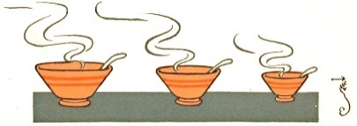
Send your child on a ‘size hunt’, encouraging them to find something which is a large, medium and small size. See if they can put the items in order of size. Use the words large, huge, medium, middle sized, small and tiny to describe the size of objects instead of ‘big/little’. This will help to not only develop your child’s understanding of size but also extend their vocabulary too.

