Pre-school Play and Learning Newsletter for 12th - 16th October 2026
Autumn, rustle, scrunch, collecting, crisp, cooler, more than, less than, same
This Photo by Unknown Author is licensed under CC BY-NC-ND

Wonder words to use with your child:

Play and Learning Highlights:
We have embraced Autumn this week and made the most of autumn leaves in many of our play & learning experiences. The builder’s tray has been full of beautiful coloured autumn leaves, logs and sticks covered in lichen in which many woodland animals have been hiding along with some Autumn treasures.
Our ‘5 Autumn Leaves’ song has been great for supporting counting practice and developing awareness of what ‘1 less’ means whilst also developing their finger muscle strength as they try to work out how to hold up the correct number of fingers. They all love the ‘ooooooo’ part of the song and happily copy this speech sound – an important skill in supporting their articulation of speech sounds.
The children enjoyed the collaborative autumn colours painting on a large branch. The children have used pine cones, leaves and brushes to create autumnal pictures. The sensation of rolling the pine cones and squishing the painty leaves fascinated many of the children and fingers and hands soon became submerged in paint! Words like squelchy, slippery and smooth were being used by them to explain the sensations – a perfect example of how real life, hand on experiences impacts on children’s vocabulary.
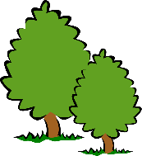Out & About sessions: We had many lovely out and abouts this week at Feadon woods looking for signs of autumn. We had a lovely time playing in the stream, floating leaves, making splashes and identifying leaves. They found different colour leaves and talked about the brown ones being older and we used our identification charts to work out what tree each leaf came from. We took a moment to listen to the water and talked about it making us feel calm x We will have more Autumn detectives next week when we are going on a climbing adventure in Illogan woods all being well.

 Sounds and Letters/language focus:

The Flying Fish have been mastering the ability to recognise how many claps (syllables) are in different words. We have used Autumn treasures where they had to select one and we would clap the word - a - corn (2 claps ) black – ber – ry ( 3 claps ) We also used all the children’s and staffs name cards to see how many claps in each person’s name. These games have really tested the children’s listening and attention skills and helps develop their awareness of the structure of words and how they are made up while also having a lot of fun!
The Starfish have been focusing on emotions, recognising theirs and their friends and naming them while doing their knee knee clap clap song each morning. We have also been practicing a lot of my turn , your turn and turn taking games during play. They have also been practicing their number and counting skills by singing the 5 Little leaves song, following the song and putting up the correct number of fingers.

Ideas to support your child at home:
* Please practise singing our ‘5 Little Leaves’ song at home with your child, encouraging them to use their fingers to show how many leaves are left.

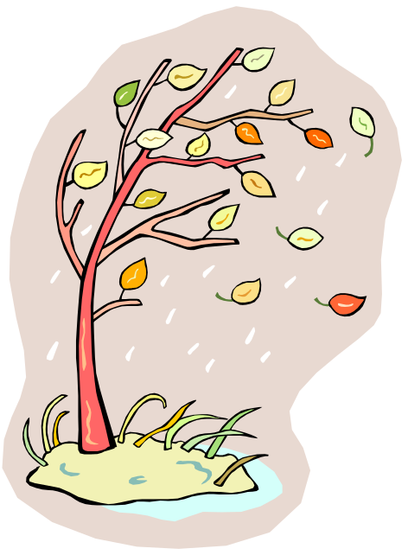 | We have been learning lots of songs about autumn leaves at pre-school at the moment. Below is one of the songs the children have really enjoyed singing. It would be lovely if you could sing it with your child at home too! It is a great song for supporting number skills, as well as using their mouths to create specific sounds (the wind howling) and listening and following actions.
5 Little leaves so bright and gay,
Were dancing around on a tree one day.
The wind came howling through the town,
ooooooo oooooooo
And 1 little leaf came tumbling down.

The song is then repeated with 4 leaves, 3 leaves and so on. The tune is ‘5 currant buns in a bakers shop’! (Please just ask for a demo from one of the adults if you’re not sure of the tune!)
Our youngest members of pre-school have been singing the song starting with 3 leaves, whilst the oldest have also been using numerals 0-5 to match with the correct amount of leaves whilst we sing it.
Whilst you sing the song, encourage your child to put up their fingers to show how many leaves are on the tree (this can be very tricky for little fingers so don’t worry if they find it difficult!). Can they make the sound of the wind blowing? Can they make their fingers ‘tumble down’ to the floor to show the leaf falling? You could collect some autumn leaves and use these whilst you sing the song. Most of all have fun!!

