Play & Learning Newsletter
14th – 18th September – 2026
Favourite, prefer, sprinkle, crumble, chop, slice, healthy, un-healthy
Wonder words to use with your child:

There have been some delicious smells during crumble making with this week’s baking buddies. This activity has been great for encouraging listening skills, concentration and physical skills which help develop finger muscle strength (essential for being able to hold marking making tools with control and co-ordination). The children enjoyed using words such as sprinkle, spoon, chop, slice as they prepared the fruit that they needed. Each week we will have new baking buddies who will bake something delicious for all their pre-school friends. Every child will get a turn to be a baking buddy over the half a term.
Other highlights this week have included:
- ramp fun with the drainpipes of various sizes and our new speed track – and some wonderful problem solving and critical thinking skills being used.
- water play with chalk paint creating in puddles and bowls. Potion making with any materials they can find in the garden such as sand, leaves and herbs – very therapeutic and calming activity.
- Painting tubes and small boxes – great for encouraging talk about shapes and imaginative use of resources.
- Role play has been so much enjoyed – it has allowed the children to practice turn taking, cooperative skills, give and take and listening to what others want compared to yourself. We have encouraged use of our short timers for turn taking and modelled how to do this. Turn taking and negotiating is a big part of the Autumn term as they all try to find their place and understand their peers want, needs and interests too. We work closely along-side them to help make this as smooth as possible.

 Sounds and Letters/language focus: We are continuing our focus on developing listening skills and this week we have used the instruments to play a ‘guess who’ game, plus lots of exploration of the different sounds the instruments make, using our self-control to beat out rhythms in songs and different levels of noise.

**Next week we are focusing on talking about our families and things we like to do at home with them. It would be great if you could send us a photo of your child’s family to the preschool email over the weekend please if you have not already so we can print it off and use it to encourage talk about family members with the other children and pre-school members.**

Ideas to support your child at home: 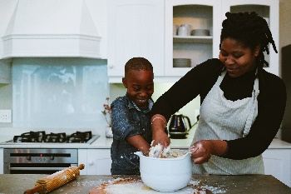
Children LOVE to help with cooking and it’s a fantastic way to develop so many different types of skills. You’d be amazed with how competent they can be given the right tools and task! Always best to get them to help when you have the time to take it slow – and more importantly – not stress about the finished product or mess involved in making it. Seeing their finished product gives children an amazing sense of pride and self-achievement, such an important feeling for little ones to experience.

