Play & Learning Newsletter

16th – 20th September – 2024

**Favourite, prefer, sprinkle, crumble, chop, slice, healthy, un-healthy**

Wonder words to use with your child:

There have been some delicious smells during crumble making with this week’s baking buddies. This activity has been great for encouraging listening skills, concentration and physical skills which help develop finger muscle strength (essential for being able to hold marking making tools with control and co-ordination). The children enjoyed using words such as sprinkle, spoon, chop, slice as they prepared the fruit that they needed. Each week we will have new baking buddies who will bake something delicious for all their pre-school friends. Every child will get a turn to be a baking buddy over the half a term.

Other highlights this week have included:

* ramp fun with the drainpipes of various sizes – and some wonderful problem solving and critical thinking skills,
* water play with chalk paint creating in puddles from the water butt– very therapeutic and calming activity and lots of splashing in the puddles and trays of water. The spray water bottles and rollers have been very well used this week with water.
* Painting tubes and small boxes – great for encouraging talk about shapes and imaginative use of resources.

***Sounds and Letters/language focus:*** We are continuing our focus on developing listening skills and this week we have used the instruments to play a ‘guess who’ game, plus lots of exploration of the different sounds the instruments make, using our self-control to beat out rhythms in songs and different levels of noise.



 **Out & About sessions:** We had an out and about on Wednesday with some more children having their first out and about adventure to the astro turf where they played lots of self-control games with balls and bubbles. Development of self-control occurs over the first five years of life and helps impulse control, the ability to plan and focus and emotional control.

We will have more out and about s each week once our new children have had their stay and play sessions and settled in.

Ideas to support your child at home: 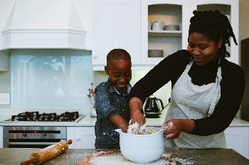

Children LOVE to help with cooking and it’s a fantastic way to develop so many different types of skills. You’d be amazed with how competent they can be given the right tools and task! Always best to get them to help when you have the time to take it slow – and more importantly – not stress about the finished product or mess involved in making it. Seeing their finished product gives children an amazing sense of pride and self-achievement, such an important feeling for little ones to experience.