Play & Learning Newsletter
20th - 24th October 2025
Pumpkin, pulp, seeds, carve, Autumn, stalk, leaf decompose/decay,
collection
Wonder words to use with your child:

We have made great use of the many different types of pumpkins which were available to buy with different skills being developed through their use in their children’s play and learning experiences. We have explored 5 very different shaped and coloured pumpkins whilst practising our number and counting skills in our ‘Five little Pumpkins’ song with pennies to spend in the pumpkin shop.
However, the most favourite experience of all was the freedom to drill and hammer, using real tools, into the pumpkins. This required excellent concentration skills and enabled the children to develop their fine motor skills in a very focused and motivated manner. The perseverance and determination that was observed by every child who engaged in this experience was truly awe inspiring to see and demonstrated that children will often rise to the challenge that is set before them if they have the inner motivation to do so. All of them understood the need to wear safety googles and not one child hurt their fingers in the process, despite all of them doing this independently. Wonderful to observe!
The builder’s tray has been full of beautiful coloured autumn leaves, logs and sticks covered in lichen in which many woodland animals have been hiding along with some of the children’s Autumn treasures. One of the stories we have been focusing on is “Pumpkin soup” by Helen Cooper this week. Attached below to listen along to. https://youtu.be/QMDLaUOpmkQ?si=HYVO7eovyDNNq81S

 Sounds and Letters/language focus: The Flying Fish have been developing their rhyming skills this week with the activities ‘Silly Soup’ and ‘The Magic Box’. Both of these activities enable the children’s ears to tune into what ‘rhyming’ means and practice the skill of being able to recognise when words rhyme. This is such an important early phonic skill as it helps children recognise similarities and differences between words and the sounds within them – essential for later reading and spelling skills.

The Starfish have spent time extending and developing their vocabulary with words and language around pumpkins and autumn treasures whilst exploring and investigating them. They joined in with the 5 little pumpkin songs using 5 real little pumpkins as props and a visual aid as one more got taken away each time. (see song below)
Out & About sessions: We have had some lovely visits to Greenfield gardens where we have enjoyed self-control games, mark making with chalks and large make making all the way along the amphitheatre making it look like a large beautiful rainbow. We had lots of chances to run freely along the amphitheatre and jump off the end. We finished with some ring games before returning back for lunch after working up an appetite.

Ideas to support your child at home:
What do you see?
This is a question that we are using with the children instead of ‘How many are there?’ or ‘What’s that?’ – it is a question that encourages the children to look and explain what they see, developing their vocabulary and explaining skills. It is also a great way of support the children’s natural skill of instantly recognising 1, 2 or 3 objects, without counting – which is something that we are working on with all of the children as recent research has now shown that this is a very important skill needed to support children to have a much greater understanding of number and concepts in mathematics. Try using it at home with your children and see how they answer differently. We are encouraging the children to instantly spot 1,2 or 3 instead of counting, if you child still counts then model saying, “Oh we don’t need to count, I can see 2 without counting”. This will help them begin to be more confident in their instant recognition.

Why not try singing our 5 Autumn pumpkins song at home ( below )

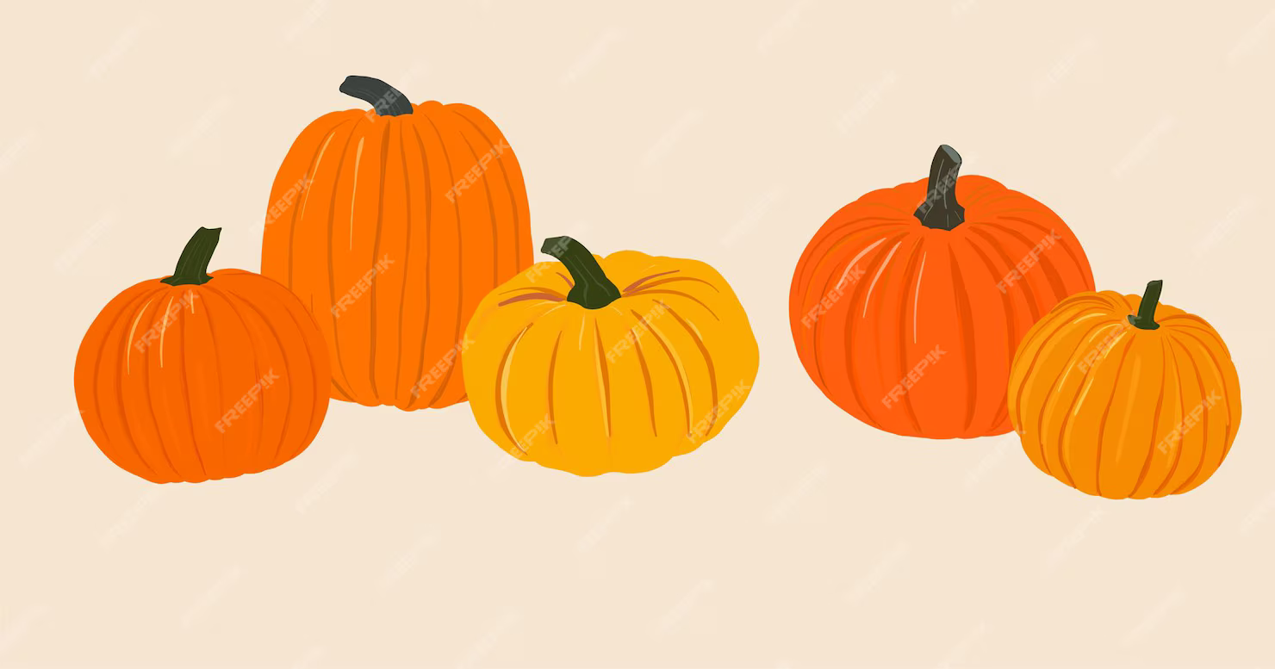
5 Autumn pumpkins
( to the tune of 5 current buns )

5 Autumn pumpkins in a pumpkin patch,
Round and bumpy with a stork on the top,
Along came ………. with a penny one day,
Bought an Autumn pumpkin and took it away.

4 Autumn pumpkins in a pumpkin patch,

Encourage showing correct number of fingers. What can you see now? ( subitising ) Focus - Compare quantities using ‘less’, show finger numbers up to 5

Have a lovely half term everyone

