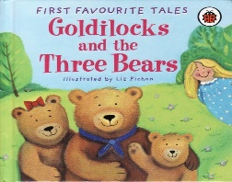 Play & Learning Newsletter

23-27th June 2025

Large, huge, medium, middle sized, small, tiny, apologize, fair, piping hot

Wonder words to use with your child:

This week we have focused on the story of ‘Goldilocks and the three bears’ – another great story for supporting the children’s language development, plus their understanding of ‘size’ words and ordering by size. The children have taken part in ‘action stories’ out in the playground and have shown a good ability to use everyday items as props in the story as we’ve acted it out. We have also had a ‘story bag’ to encourage retelling with a set of 3 bears. Both these activities have prompted some superb ‘voices’ for the different characters – we have some great budding actors 😊.

The Three Bears cottage has been located in our role play areas too and we used the song ‘When Goldilocks went to the house of the bears’ to inspire the children’s play in these. There has been lots of food making with pasta in the cereal dispenser, with the children exploring how to make the dispensers work and which utensil belonged to which bear.

The children have loved the sensory soup in the top room with shaving gel, corn flour, flower and herbs and lots of different size pots. We added pump bottles with different coloured water to help with their potion making and to promote fine motor skills. The children have really used their imagination to make up different potions and got completely immersed in their play. We have heard lots of language relating to size, amounts and positional language while they have played and invented.

***Sounds and Letters/language focus:***



This week we have played games using the story of Goldilocks as a stimulus for listening carefully and then responding. We had lots of listening games to practice tuning into sounds. They loved the sound lotto game on YouTube. The children joined in with sound and action stories in the garden. Starfish have been singing lots of songs and reading stories around goldilocks and the three bears.

**Out and abouts –** We decided to not visit Harbour house this week with this awful virus going around. We most definitely did not want to share that with them! We did however manage to take Flying fish children to their first stay and play at Portreath school. They had so much fun exploring the resources and meeting new friends and their teachers. They were all very confident, polite and very sensible throughout.

Ideas to support your child at home: 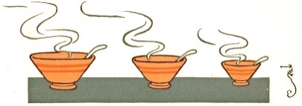

Send your child on a ‘size hunt’, encouraging them to find something which is a large, medium and small size. See if they can put the items in order of size. Use the words *large, huge, medium, middle sized, small and tiny* to describe the size of objects instead of ‘big/little’. This will help to not only develop your child’s understanding of size but also extend their vocabulary too.

Daddy Bear Song

Sung to tune of Tommy Thumb.

Draw Daddy bear on thumb, mummy bear on index finger and baby bear on little finger. Draw goldilocks on other hand on the index finger. Just two dots and a smile on each finger

Use deep voice for daddy bear, normal voice for mummy and squeaky voice for baby.

Goldilocks sings at the end – Here I am, Here I am – I’m sorry boo hoo hoo.

Ask the children ‘why is she sorry?’ Hold all fingers closed and open up the correct one when sung.

**Daddy bear, Daddy bear, where are you?**

**Here I am, here I am, how do you do.**

**Mummy bear, Mummy bear, where are you?**

**Here I am, here I am, how do you do.**

**Baby bear, Baby bear, where are you?**

**Here I am, here I am, how do you do.**

**Goldilocks, Goldilocks, where are you?**

**Here I am, here I am, I’m sorry boo hoo hoo.**