Play & Learning Newsletter

22nd – 26th February 2021

Dragon, castle, cave, feast, terrified, fierce, mighty, reward, moat and drawbridge

Wonder words to use with your child:

Over the past few weeks we have noticed that many of the children have been very into playing games involving dragons. To harness this interest we decided to use the fantastic book of ‘George and the Dragon’ by Chris Wormell to inspire our play and learning experiences this week. This is a super story of how a little mouse inadvertently saves a princess from the jaws of a dragon. It has wonderful language in it which the children have been using throughout the week in both their free play and discussions in group times. The word ‘terrified’ and ‘mighty’ have been particularly popular ones!

Our home corner has become a castle where the children have been busy baking and decorating cakes for George the mouse to eat. We have included a photographic cookery book in there for them to use which has been really good for encouraging following instructions and sequencing. The playdough table has also been a hive of industry as the children created a ‘feast’ for George (his reward for saving the princess) whilst also exploring and developing their 2D shape knowledge.

Some surprise dragon guests (purchased with some of our fundraising money) arrived at pre-school this week too and have provided lots of inspiration for castle building. The creating and construction areas have been the scene for some super creations with drawbridges and towers with turrets using junk modelling and wooden blocks. The children have been finding out how best to join things together whilst creating and building and how to create stable structures which will take the weight of a dragon.

Friday saw budding storytellers created their own versions of ‘X and the dragon’ which prompted some lovely language development in their articulation of how they would save the princess and what they would get to eat as their reward.

***Sounds and Letters/language focus:***



This week we have introduced the letter sound ‘d’ in our ‘Sound box’ and through a game involving feeding a dragon. The Flying Fish children are all showing a real interest in letters and sounds and we have a wall of magnetic letters up at the moment which they are enjoying using to find the letters we have learnt so far plus the letters in their name. We would highly recommend getting some magnetic letters for the fridge, for example, so that your child can develop this interest at home as well. Although there is absolutely no need for Flying Fish children to know letter sounds before they go to school it does help if they are interested in them and beginning to know the letters in their own names. Playing with magnet letters is a good way of encouraging this interest.

The Starfish have been playing games which involves listening to and copying a partners ‘sound’ created by an instrument. A fun way of developing listening skills!

Ideas to support your child at home:

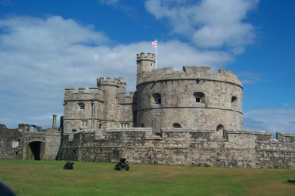

The weather is looking to be beautiful this weekend so if you happen to be out and about in the village see if your child can find the castle in Portreath. Encourage them to tell you who they think lives there and what they do. Do they think a mouse like George lives in the castle. Can they spot a little hole which he might live in? (George the mouse in the story gets rewarded with a ‘cosy little hole in the castle wall’)

If you happen to go down to the beach maybe they can build a castle from sand and rocks. Can they make a home for George in their castle wall? Can they make a feast for him using things they find on the beach?