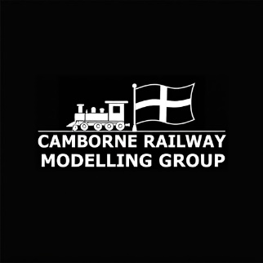
Presents
Camborne Railway Modelling Group

A Special Fundraising Exhibition
For
Portreath Pre-school
Sunday 15th February 2026
10am – 4pm
Millennium Hall
3 Penberthy Road
Portreath
Redruth
TR16 4LP
Admission £3, Under 5’s go free!*
(Children Must be accompanied by adult)
Lots of layouts in a variety of scales
Trade Support
Refreshments Available
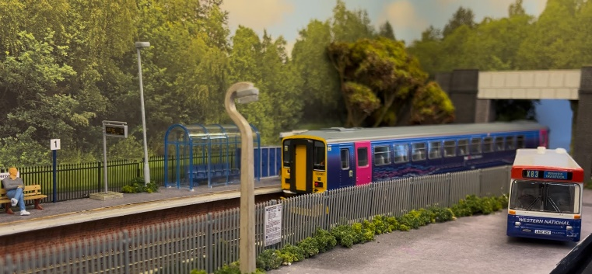
*All proceeds to go towards the running of the pre-school

