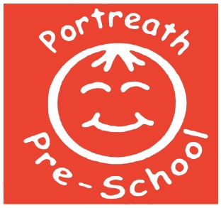

Staff Use of Social Networking Sites Policy
Social media, professional networking sites, rapid-fire communications, blog sites, and personal Web sites are all useful technologies; Portreath Pre-school realises this fact. Every employee has an opportunity to express and communicate on-line in many ways, and we do not wish to discourage an on-line presence. Above all else, everyone needs to use good judgement on what material makes its way on-line.
This policy will set out guidelines that employees should follow for all on-line communications in reference to Portreath Pre-School.

Responsibility
Any material posted on line in reference to Portreath Pre-School by any employee is the responsibility of the poster. At no times should any posts be made in reference to Children, Parents or other professionals that employees may come in to contact with through work. At no time must any photographs or materials be published that identify the setting or Children and pictures of staff may only be used with the express permission of the staff members concerned. Any member of staff found to be posting remarks or comments that breach confidentiality or are deemed to be of a detrimental nature to the company or other employees or posting/publishing photographs of the setting, children or staff unless staff permission has been gained will face disciplinary action in line with the company disciplinary procedures.
Topic matter guidelines
Portreath Pre-School employees are encouraged to use the following guidelines in social networking practices:
- Remember that no information sent over the web is totally secure and as such if you do not wish the information to be made public refrain from sending it over a social network site.
- Even though you may think you are anonymous or use an alias you may be recognised.
- Maintain professionalism, honesty, and respect.
- Apply a "good judgement" test for every activity related to Portreath Pre-School; could you be guilty of leaking information, discussing confidential information? Is it negative commentary regarding Portreath Pre-School or its employees?
Activity showing good judgement would include statements of fact about Portreath Pre-School and its products and services, facts about already-public information, or information on the setting Web site.
Any member of staff referring to the children, parents/carers, colleagues or other work related matters will risk facing disciplinary action.
Staff are asked NOT to request parents as ‘friends’ on social networking sites, however if parents request you, use your judgement as to whether you should accept the request or not - are you friends with them outside of the setting? If not we would suggest you do not accept their request.

Personal posts
Remember that at all times you are representing the setting - whether posting about us or not - so please think carefully about whether what you are posting shows you in a professional light. For example it is not acceptable to advertise how drunk you might have got, or to post unsuitable photo's etc.
Parents
Parents must be reminded that they are not permitted to post photographs, which may contain images of children other than their own to Social Networking sites with regards to Portreath Pre-school; for example group photographs from Sports Day or an Outing.

This policy was adopted by the pre-school on : 10.01.2018
Last reviewed: 29.03.2022 – no changes made

